#include<stdio.h>

int fibo(int n);

int main(){

printf("enter 1 to continue and 0 to exit\n");

int i;

scanf("%d",&i);

while(i){

int n;

printf("enter n \n");

scanf("%d", &n);

int j=0;

while(j<n){

printf("%d\t",fibo(j));

j++;

}

printf("\nenter 1 to continue and 0 to exit \n");

scanf("%d",&i);

}

}

int fibo(int n){

int res=0;

if(n==0||n==1){

res+=1;

}

else{

res=fibo(n-1)+fibo(n-2);

}

return res;

}

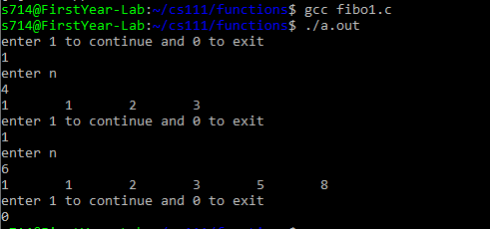

#include<stdio.h>

#include<math.h>

int xn(int x,int n);

int main(){

int x,n;

printf("enter x and n respectively \n");

scanf("%d %d",&x,&n);

printf("the taylor series sum is %d \n",xn(x,n));

}

int xn(int x,int n){

int result=0;

if(n==0){

result+=1;

return result;

}

else{

result=pow(x,n)+xn(x,n-1);

}

return result;

}

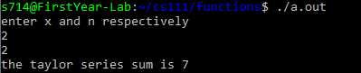

#include<stdio.h>

int fact(int n);

int npr(int n,int r);

int main(){

int i;

printf("enter 1 to continue and 0 to exit \n");

scanf("%d",&i);

while(i){

int n,r;

printf("enter n,r \n");

scanf("%d %d ",&n,&r);

printf("%dp%d = %d",n,r,npr(n,r));

printf("\nenter 1 to continue and 0 to exit \n");

scanf("%d",&i);

}

}

int fact(int n){

int res=1;

if(n>1){

for(int i=1;i<=n;i++){

res\*=i;

}

}

else if(n==1 || n==0){

res=1;

}

return res;

}

int npr(int n,int r){

int final;

final=fact(n)/fact(n-r);

return final;

}

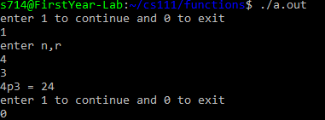

#include<stdio.h>

int leap(int n);

int main(){

int n;

printf("enter the year \n");

scanf("%d",&n);

leap(n);

}

int leap(int n){

if(n%4==0){

if(n%100!=0){

printf("the year is a leap year \n");

}

else if(n%100==0 && n%400==0){

printf("the year is a leap year \n");

}

else{

printf("the year is not a leap year \n");

}

}

else{

printf("the year is not a leap year \n");

}

}

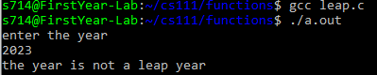

#include<stdio.h>

#include<string.h>

int strlength(char str[]){

int length=0;

for(int i=0;str[i]!='\0';i++){

length++;

}

return length;

}

void strcopy(char str1[],char str2[]){

int i;

for(i=0;str1[i]!='\0';i++){

str2[i]=str1[i];

}

str2[i]='\0';

}

int strcompare(char str1[],char str2[]){

int i,result;

for(i=0;str1[i]!='\0' && str2[i]!='\0';i++){

if(str1[i]!=str2[i]){

break;

}

}

if(str1[i]=='\0' && str2[i]=='\0'){

result=0;

}

else if (str1[i]>str2[i]){

result=1;

}

else{

result=-1;

}

return result;

}

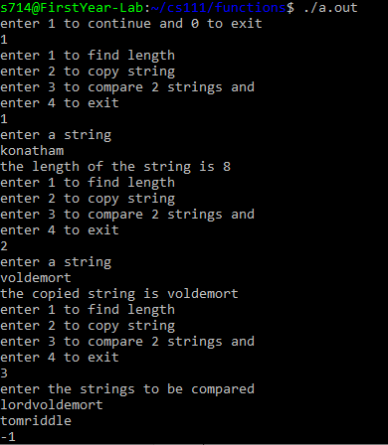

void read(int arr[],int size){

for(int i=0;i<size;i++){

printf("enter the %d element \n",i+1);

scanf("%d",&arr[i]);

}

}

void display(int arr[],int size){

printf("the elements of the array are \n");

for(int i=0;i<size;i++){

printf("%d \t",arr[i]);

}

printf("\n");

}

void sort(int arr[],int n){

int i,j,temp;

for(int i=0;i<n;i++){

for(j=0;j<n-i-1;j++){

if(arr[j]>arr[j+1]){

temp=arr[j];

arr[j]=arr[j+1];

arr[j+1]=temp;

}

}

}

}

int main(){

int arr[100],n;

printf("enter the size of the array \n");

scanf("%d",&n);

read(arr,n);

sort(arr,n);

display(arr,n);

}

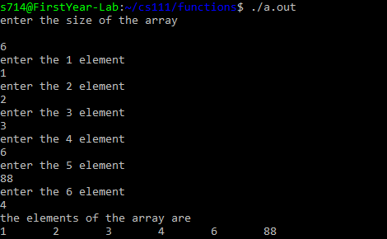

#include<stdio.h>

int binarysearch(int arr[],int l,int r,int key){

int mid;

if(l<=r){

mid=(l+r)/2;

if(arr[mid]==key){

return key;

}

else if(arr[mid]>key){

return binarysearch(arr,l,mid-1,key);

}

else {

return binarysearch(arr,mid+1,r,key);

}

}

return -1;

}

int main(){

int arr[100],i,n,key,result;

printf("enter the size of the array \n");

scanf("%d",&n);

for(int i=0;i<n;i++){

printf("enter the %d element of the array \n",i+1);

scanf("%d",&arr[i]);

}

printf("enter the element to be searched \n");

scanf("%d",&key);

result=binarysearch(arr,0,n-1,key);

if(result==-1){

printf("element is not found \n");

}

else{

printf("element is found at %d position",result);

}

}

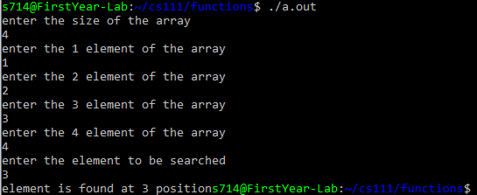

#include<stdio.h>

#include<math.h>

double fact(int n){

if(n==0 || n==1){

return 1;

}

return n\*fact(n-1);

}

double factsum(int n){

static double sum=0;

if(n==0){

return sum;

}

sum+=(1/fact(2\*n-1));

return factsum(n-1);

}

int main(){

int n;

double result;

printf("enter the value of n \n");

scanf("%d",&n);

result=factsum(n);

printf("the sum of the series is %lf \n",result);

}

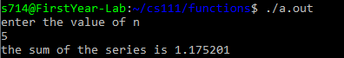

#include<stdio.h>

#include<string.h>

void reverse(char \*str,int start,int end){

char temp;

if(start>=end){

return ;

}

temp=\*(str + start);

\*(str+start)=\*(str+end);

\*(str+end)=temp;

reverse(str,start+1,end-1);

}

int main(){

char str[100];

printf("enter the string \n");

scanf("%s",str);

reverse(str,0,strlen(str)-1);

printf("the reversed string is %s \n",str);

}



#include<stdio.h>

int biggest(int arr[],int start,int end){

int max;

if(start==end){

return arr[start];

}

max=biggest(arr,start+1,end);

return arr[start]>max?arr[start]:max;

}

int main(){

int arr[100],n,result;

printf("enter the number of elements \n");

scanf("%d",&n);

printf("enter the elements \n");

for(int i=0;i<n;i++){

scanf("%d",&arr[i]);

}

result=biggest(arr,0,n-1);

printf("the biggest number is %d \n",result);

return 0;

}

